TATRA, a.s.
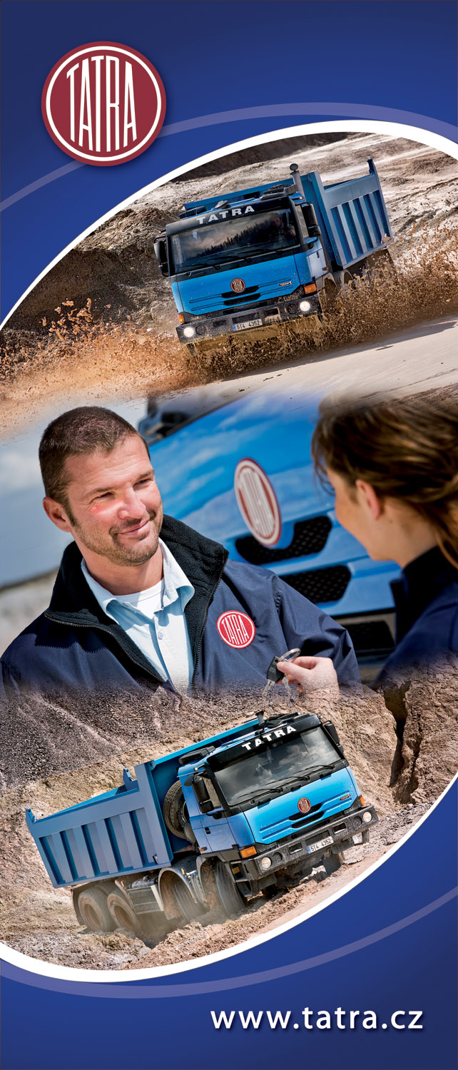
Producer of heavy-duty off-road trucks and trucks for combined off-road and on-road transportation is seeking for its newly built marketing team a suitable candidate for the position of:

PERSONAL ASSISTANT TO CHIEF MARKETING OFFICER

Responsibilities:
- Organize meetings, visits, and other events for the marketing group
- Administer and monitor team plans, agendas, tasks, meeting minutes, purchase orders, invoices, travel arrangements and reimbursements
- Support and actively participate in Shows, Fairs, and Exhibitions
- Preparation of presentation documents, handling and processing other documents
Requirements:
- Higher or university education with marketing major preferred
- fluent English and Czech required (both written and verbal), competency in other languages a plus (Russian, German, Polish, ..)
- working knowledge of MS Office required
- good organizational skills
- personable and good people skills
- prior experience in similar position preferred
Offering:
- work with creative and open-minded people
- career growth opportunities
- competitive remuneration with performance bonus
- other employee benefits

Contact: TATRA, a.s.
HR Department – Libor Bartoň, phone:+420 556492438,
email: libor.barton@tatra.cz
Areál Tatry 1450/1, Kopřivnice, 742 21, Czech Republic

